**Vehicle Registration API document**

# **Document Control**

## **Purpose of this Document**

The purpose of this document is to provide enough information about the Vehicle Registration API.

# **Vehicle Registration API**

## **Description:**

This API is used to register vehicle details and get the vehicle details when required.

## **Operations:**

There are 3 operation in vehicle registration API

|  |  |  |
| --- | --- | --- |
| **Operation** | **HTTP Method** | **Route** |
| NewVehicle | POST | /api/NewVehicle |
| GetAllVehicles | GET | /api/GetAllVehicles |
| GetVehicleDetails | GET | /api/GetVehicleDetails/{vehicleNumber} |

**NewVehicle:**

Content-Type: application/json

Body:

{

    "VehicleNo": "DEF345", // Should be pattern 3 characters and 3 numeric

    "Year": 2010, //Year should be between 1960 and 2021 (inclusive)

    "Make": "Swift" // Should exceed more than 10 characters

}

**Test Result:**

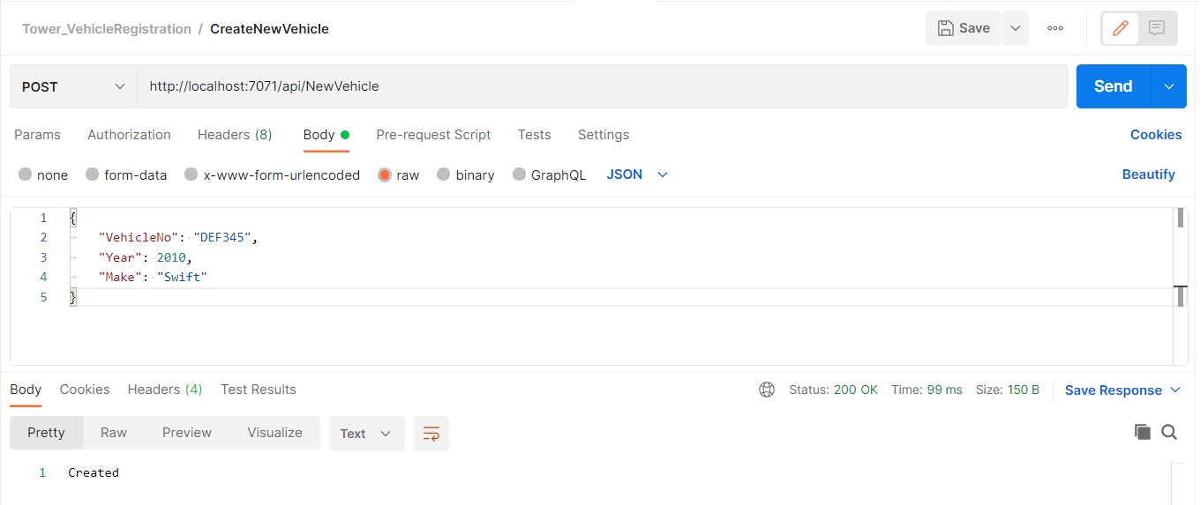

**Input Validation test:**

# Provided invalid vehicle number

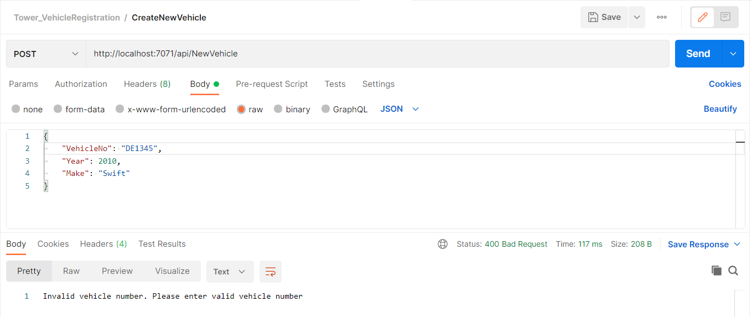

# Provided invalid year

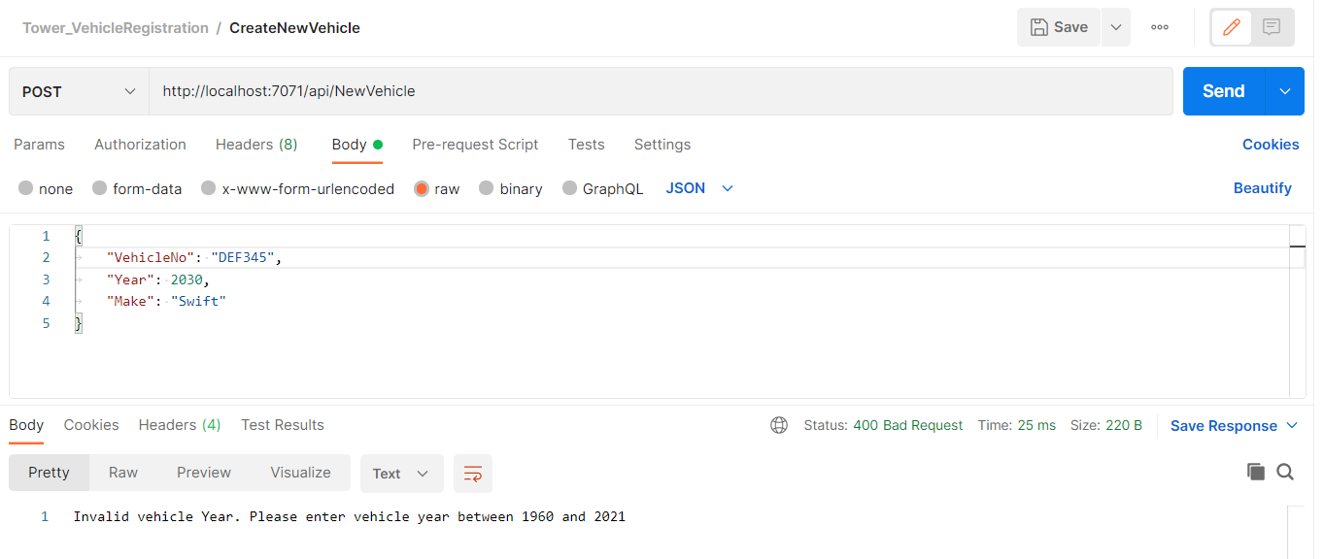

# Provide Make characters more than 10

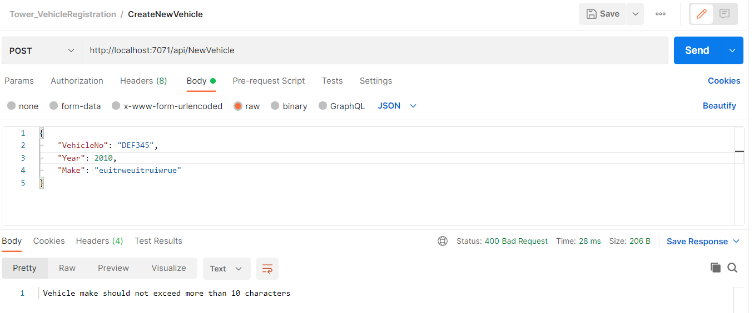

GetVehicleDetails:

#Success Response

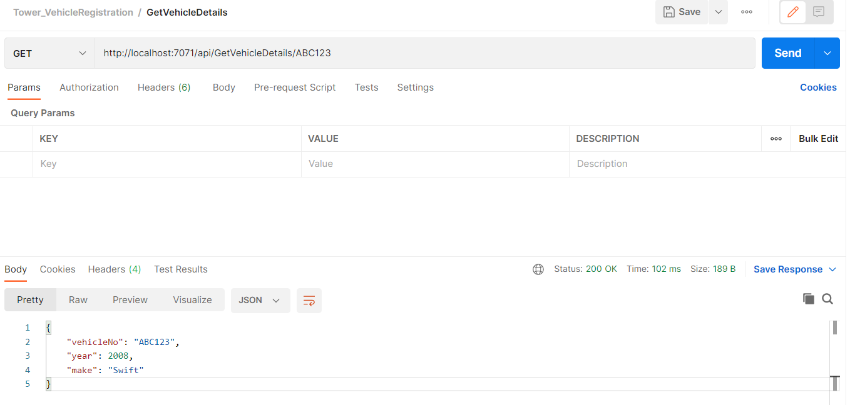

#No Record Found

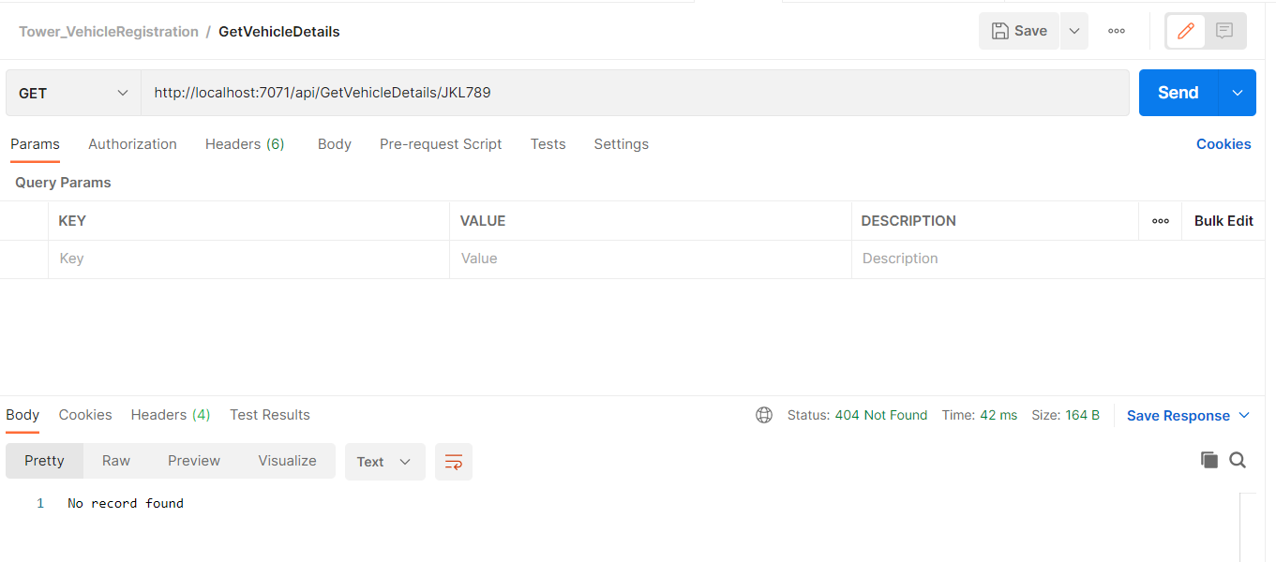

GetAllVehicles:

#Success Response

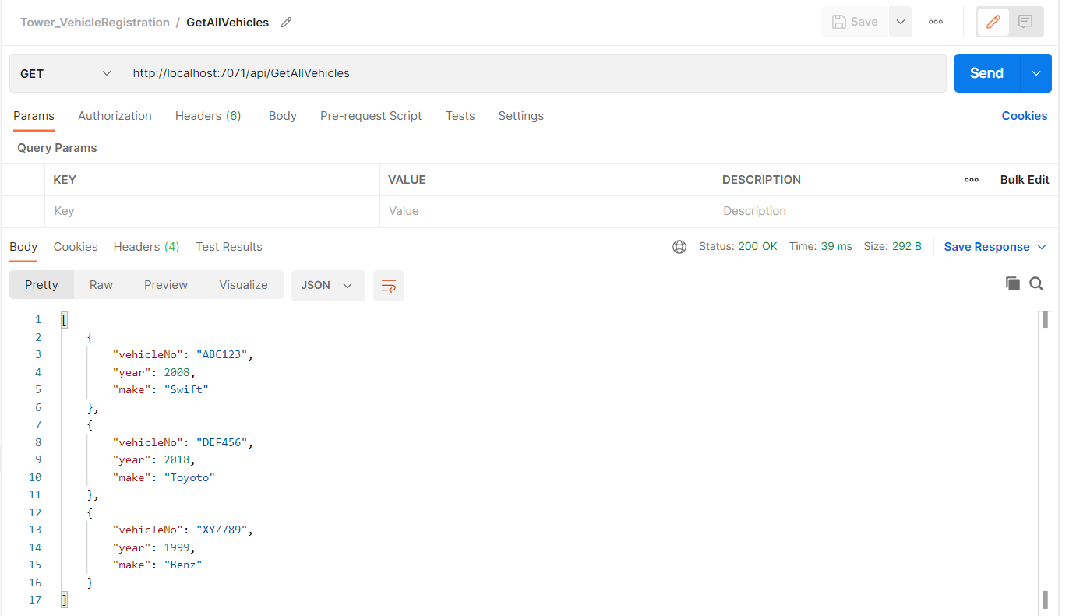

#No Vehicle registered

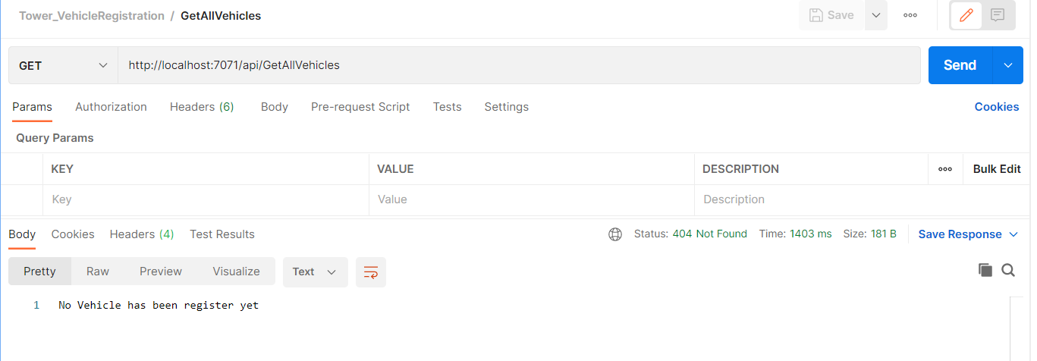

**Unit Tests:**

